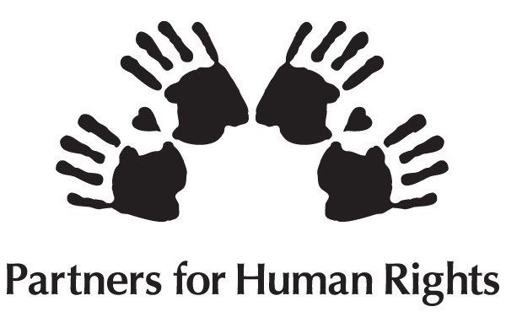
Call for Nominations: Nova Scotia Human Rights Awards 2018
Deadline: Friday, November 9, 2018, 4:30 p.m.

Do you know a youth, individual, or organization that is doing or has done great work and would be deserving of a Nova Scotia Human Rights Award?

The Nova Scotia Human Rights Awards, presented annually by the Nova Scotia Human Rights Commission, acknowledge the good works done by Nova Scotians who advance human rights in the province.

Human rights are those conditions, expectations, and standards to which every person by virtue of his or her existence as a human being, is entitled. When the United Nations adopted the Universal Declaration of Human Rights in 1948, it declared that all human beings are “free and equal in dignity and rights.” Some human rights, such as freedom of religion, are fundamental freedoms. Other human rights protect people from unfair treatment because of certain personal qualities. These are sometimes called “anti-discrimination” rights.

The following information outlines the eligibility, criteria, and the nomination and selection processes for the Nova Scotia Human Rights Awards.

CRITERIA AND ELIGIBILITY
There are three categories for awards: Youth, Individual and Organization:

Youth Award
- Up to age 19

Individual Award
- Individuals over the age of 19

Burnley Allan “Rocky” Jones (Individual) Award
- An individual over the age of 19 whose work organizing and advocating for the rights of a marginalized community has brought lasting change.

Organization Award
- An entity where two or more persons work together to achieve a goal
- Individuals form a group and work as a whole to achieve a common end purpose
- There is a structure in place to support the achievement of the common goal

Criteria for all nominations:
- The youth, individual, or organization lives or operates in Nova Scotia.
- The nominee espouses human rights values and does not discriminate based on race, gender, disability and other protected characteristics of the Nova Scotia Human Rights Act.
- A nominee has not received an award within the last five years.
- The nominee’s work includes a component of education and leadership, and has impact.
- Their work promotes non-exclusionary practices, such as practices not in the contravention of the Human Rights Act
- The creativity behind the advancement and protection of human rights in Nova Scotia.

NOMINATIONS:
Please complete the attached nomination form and submit with two references. The application deadline is 4:30 p.m., Friday, November 9, 2018.

SELECTION PROCESS:
- A Human Rights Award Committee, comprised of Commission staff and Partners for Human Rights review and assess the nominations based on award category (youth, individual, organization)
- Nominations that meet the selection criteria are then sent to the Nova Scotia Human Rights Commissioners, who select the award recipients.
- The recipients of the Human Rights Award are announced by press release, and awards are presented at an International Human Rights Day event on December 10, 2018.

For more information on the Nova Scotia Human Rights Awards, please visit our website: humanrights.novascotia.ca.

Return the form and attachments by Friday, November 9, 2018, 4:30 p.m., to:

Mail: Nova Scotia Human Rights Commission
Attn: Human Rights Award Committee Chair
PO Box 2221
Halifax NS B3J 3C4
Fax: 902-424-0596

E-mail: HRCinquiries@novascotia.ca
Questions? Call 902-424-2637

CHECKLIST:
- Nomination Form
- Two reference letters
- Additional supporting documentation, as needed
Human Rights Award Nomination Form
The application deadline is Friday, November 9, 2018

Information on your nominee (please check one category):
Note if you have multiple nominations, each will require a separate form and supporting package of materials.
Youth Individual Burnley Allan “Rocky” Jones Organization/Group

Name of the nominee: __________________________________________________________________

Your contact information:
Name: _______________ E-mail________________ Phone number: _____________

1. Details of the nomination:
(i) (for youth/individuals) Why are you nominating this youth or individual? Please indicate the specific initiative(s) or project(s) or actions for which they are being nominated (attach additional information as deemed necessary): (500 words)
_____________________________________________________________________________________
_____________________________________________________________________________________

(ii) (for organizations) Why are you nominating this organization? Please provide details on its common purpose and indicate if there is a specific initiative or program you would like to highlight (attach additional information as deemed necessary): (500 words)
____________________________________________________________________________________
2. What is your current experience with the nominee? (250 words)
____________________________________________________________________________________
____________________________________________________________________________________

3. Who would have benefited from the work of the nominee and what has their impact been? (500 words) __________________________________________________________________________________________________________________________________________________________________________________________________________
4. Explain how the nominee fits the selection criteria (see above Criteria and Eligibility) (500 words - attach additional information as deemed necessary)
__________________________________________________________________________________________________________________________________________________________________________________________________________________________________________________________________________________________________________________
5. Please attach any additional document(s) that you feel support your nomination This is optional, and documents should only be attached that are intended to bolster the nomination. For example, you may wish to include brochures, posters, reports, the organization’s mandate and mission, purpose, any website information applicable, testimonials, etc.

